# RELATING UNIFORM STOCK DATABASE RECORDS TO IMS DETAIL RECORDS

## PURPOSE

As we transition from the existing uniform issue process to the Inventory Management System (IMS) it will be important to relate records from the Uniform Stock Database (USDB) object to the new IMS Detail (IMD) object.

The major difference between the two methods is the USDB was able to issue items and return items, but isn’t a very good inventory management system. The IMS system is a complete inventory app.

## STOCK KEEPING UNITS (SKU)

A stock keeping unit (SKU pronounced “skew”) is a product identification code for a product, often displayed as a machine-readable bar code that helps track the item for inventory.

SKUs are sometimes thought to be synonymous with UPC bar codes, but they are not. A SKU is an internal code that each business can create for itself. A UPC, however, is the same no matter who sells the product.

SKU’s are unique and are never to be reused.

SIS will be using the vendor assigned SKU or an internal 8 digit SKU Number assigned sequentially if a vendor SKU isn’t supplied.

## What a SKU is Not

SKUs are sometimes thought to be synonymous with UPC bar codes, but they are not. A SKU is an internal code that each business can create for itself. A UPC, however, is the same no matter who sells the product.

## IMS METHODOLOGY

The system is designed to easily manage inventory items using a Parent / Child relationship for items.

The parent (IMS) items are the control items and contain the base information. Think of the base information of an item as the manufacture, style, color and features. These values don’t change. What changes is the size. So for each Parent item the size records, or what changes is maintained in the child (IMS Detail) record.

### Example

Port Authority K540

PARENT ITEM (IMS)

Port Authority Silk Touch Performance Polo Shirt Short Sleeve K540 Steel Grey

CHILD ITEMS (IMD)

|  |  |
| --- | --- |
| SKU | ITEM |
| 00000518 | Port Authority K540 XS |
| 00000519 | Port Authority K540 S |
| 00000520 | Port Authority K540 M |
| 00000521 | Port Authority K540 L |
| 00000522 | Port Authority K540 XL |
| 00000523 | Port Authority K540 2XL |
| 00000534 | Port Authority K540 3XL |
| 00000524 | Port Authority K540 4XL |

The problem is resides with the USDB system that serialized each item, each item had a unique item number. Some of the unique identifying features were kept in the description and was inconsistent.

IDENTIFY THE USDB RECORDS TO RELATE TO IMD RECORDS

IMPORTANT: The process described below uses Salesforce Lightning.

When a USDB record is related to an IMD record the related IMD record entered in the IMS Detail field. This process will help identify the USDB records that are missing the IMS Detail relationship.

1. Select the Utilities Lightning

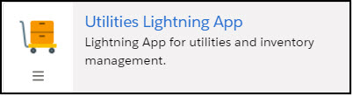

1. Select the Uniform Stock Databases tab

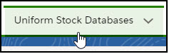

1. Select the List View IMS Detail to Match

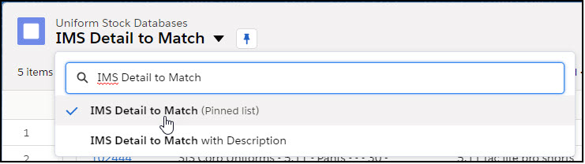

### IMS Detail to Match

This view is shared with Utilities and System Administrators. Clone this view and work with your own copy otherwise each change you make will affect the view for everyone else.

The basic view will show all the items where Retired Item is false and IMS Detail is empty.

### Clone IMS Detail to Match

1. Click the List View controls gear icon.

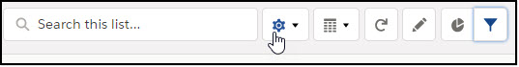

1. Select Clone from the pop up menu

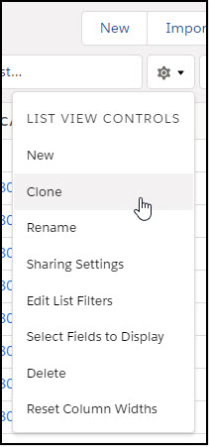

1. Clone List View
   1. Enter List Name
   2. Accept the default for the List API Name
   3. Select Only I can see this list view
   4. Click [Save]

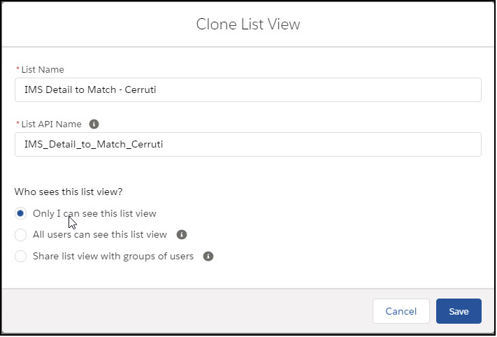

1. You may want to pin this view for your convenience while performing this task,
   1. Click the pin icon next to the List View name.

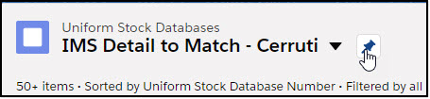

### Filter Based on Item Type

Now let’s add filters for Item Type, Pants

1. Click the Add Filter link

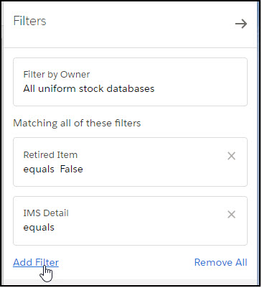

1. Select Field Item Type
2. Select Operator Equals

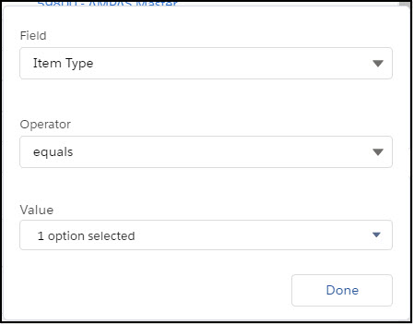

1. Select Value Pants

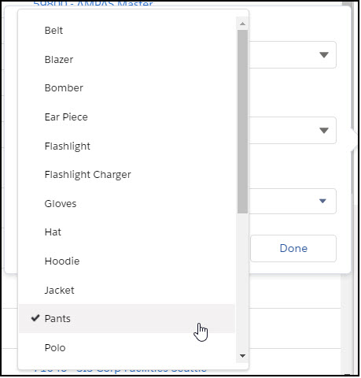

1. Click the [Done] button

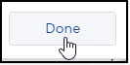

### Add Additional Filters

1. Manufacturer equals 5.11 (This can be any manufacturer)
2. Manufacturer Stock Number not equal to 0 options selected
3. Size equals 0 options selected
4. Waist not equal to 0 options selected
5. Length not equal to 0 options selected
6. Description not equal to
7. Click [Save]

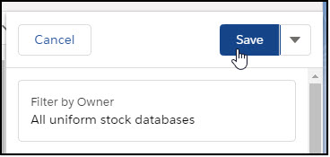

1. Click the collapse list view filters button

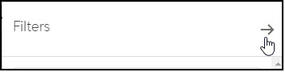

Review the results of your filters. Select a Manufacturer Stock Number, Size, Waist and Length. Description key words such as “Taclite pro KHAKI”

### Update Filters

Open the Filters sidebar by clicking the Show Filters button.



For this example use:

1. Manufacturer Stock Number equals 74273
2. Size: 0 options selected
3. Waist: 30
4. Length: 32
5. Description contains “Taclite pro KHAKI.”

Note the number of records found at the top left of the list view.

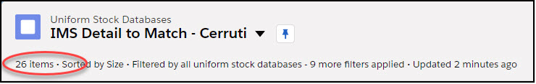

## IMS DETAILS TO MATCH

Now that you have a list of records to update you need to determine the IMD record to match them up to.

1. Select the IMS tab

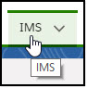

1. Select the List View All Clothing by Manufacturer
2. Clone a copy for you to use
3. Update the filter criteria
   1. Type equals Pants
   2. Manufacturer contains 5.11

From this list select the IMS record that matches the USDB criteria.

### Review IMS Detail Records

1. Open the record by clicking on the link

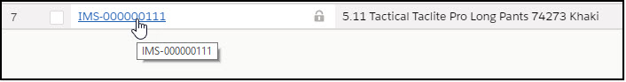

1. Select the IMS Details tab

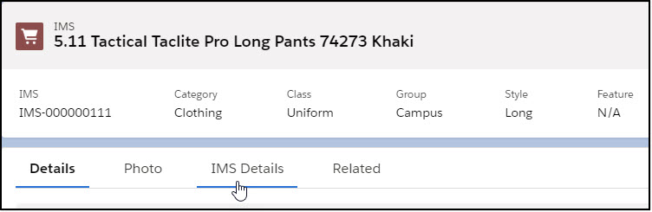

1. Click the View All link

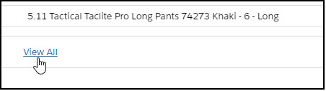

## MATCH USDB RECORDS TO IMS DETAIL RECORDS

### IMS Match

IMS Match is a Salesforce Flow that will search for both USDB records and IMS Detail records based on a set of criteria.

Have easy access to both the IMS Detail records you have open from the All Clothing by Manufacturer (Clone) List View and IMS Detail to Match (Clone)

To access the IMS Match flow, navigate to the Uniform Stock Database tab and select any List View besides Recently Viewed. A good view would be the IMS Detail to Match view that you cloned and pinned.

1. Open two tabs with the IMS Detail to Match list view.
2. From one of the tabs click on the IMS Match button on the top left. You might have to click on the down arrow to display the IMS Match button.

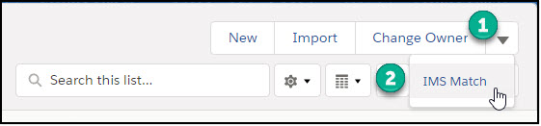

1. Enter the same filter criteria used in the IMS Detail to Match list view
   1. Item Type: Pants (Note: this seems to be the field most likely to forget to change)
   2. Manufacturer: 5.11
   3. Manufacturer Stock Number: 74373
   4. Size: No Choice
   5. Waist: 30
      1. Note: If Waist is entered for the USDB criteria it will be converted to Size for the IMS Detail match. IMS Detail records don’t have a “Waist” field.
   6. Length: 32
   7. Description: pro khaki (The flow will look to match the Description field that contains the phrase entered. Usually two words are sufficient, but must be in the same order as they appear in the Description field. This is case insensitive. NOTE: Do not use punctuation like “,” and “ ‘ “)
   8. IMS Description: 74273 Khaki (The flow will look to match the Item Description field on the IMS Detail record that contains the phrase entered. Usually two words is sufficient, but must be in the same order as they appear in the Description field. This is case insensitive. NOTE: Do not use punctuation like “,” and “ ‘ “)

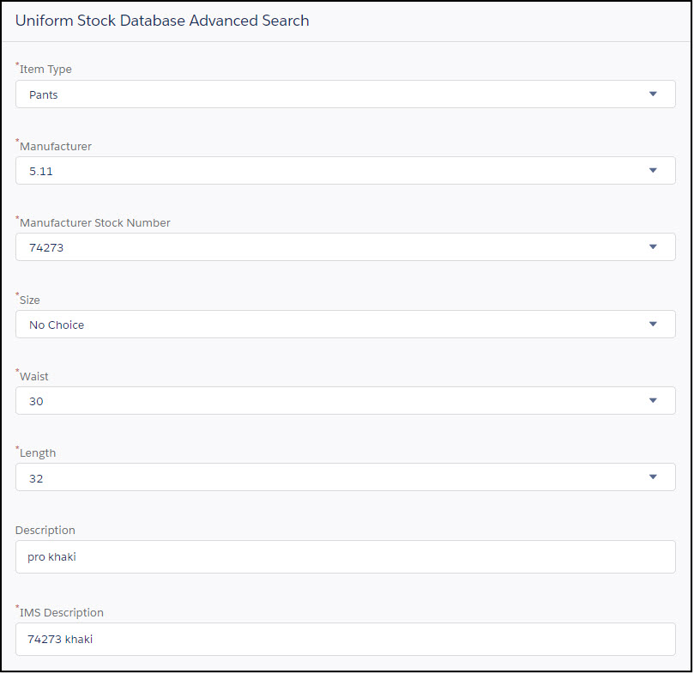

* 1. Click the [Next] button

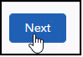

1. Note Total Records Found should match items from the IMS Detail to Match list view.

Total Records Found



Items

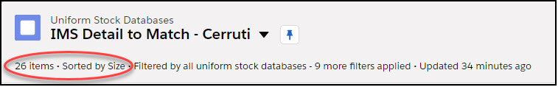

1. If these numbers match you can choose Update All Records

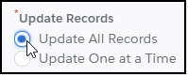

1. Select the IMS Records to Match. Always check because there could be more than one option.
   1. If this drop down is empty no items will be related. This probably means that there isn’t an IMS Detail record for this criterion.

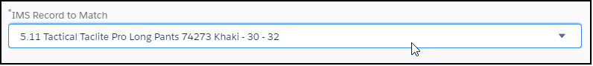

1. Click the [Next] button (If the list is long you may have to scroll down to see the [Next] button)
2. You will receive a confirmation screen for the total records updated

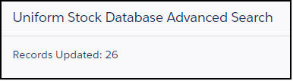

Return to the tab with the IMS Detail to Match list view and click the refresh button.

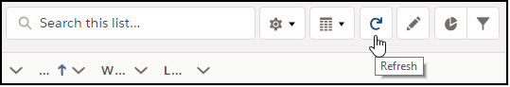

The list view should now have 0 items.

### Update One at a Time

Update the filter for the list view IMS Detail to Match to find the next group of records.

Work one manufacturer number at a time. Work all records with the same waist by changing the Length filter to not equal to blank by removing previously selected values.

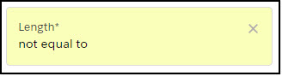

This will return a data set of all records that have Length not equal blank. Select the next Length and update the filter again, changing Length equal to that value.

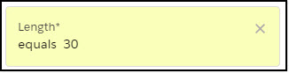

1. Start IMS Match flow
2. Enter the filter criteria as before and click the [Next] button
3. Select Update One at a Time
4. Click the [Next] button
5. Review the summary for the record to be updated

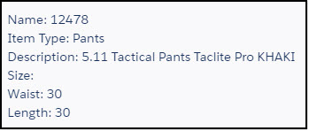

1. Verify the IMS Detail Record in the IMS Detail drop down.
2. Select Update
   1. Select Update to update that record

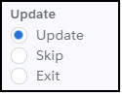

* 1. Select Skip to move to the next record

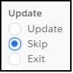

* 1. Select Exit to quit updating records

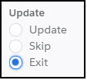

* 1. Click the [Next] button

After updating the record, return to the tab with the IMS Detail to Match list view and click the refresh button. There will be one less.

### Create New IMS Detail Record

When the IMS Record to Match is blank a new record might need to be created.

Return to the IMS Details page and scan the records for the size and length.

To create a new record follow these steps:

1. From the IMS Details page click the IMS link at the top.

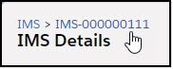

1. Click the Create Clothing Detail Item button

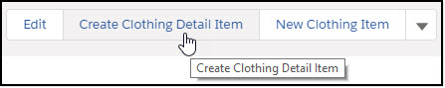

1. Create Clothing Detail Item
   1. Size
   2. Length
   3. Cost
   4. Click the [Save] button

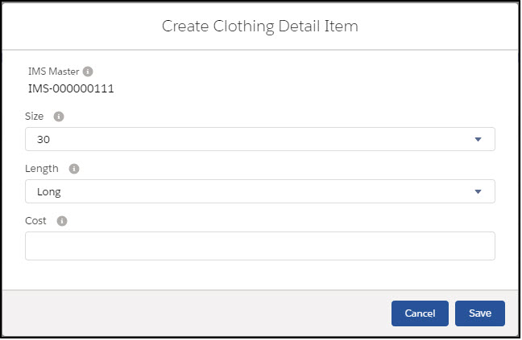

1. Return to the IMS Flow
2. Click the [Previous] button
3. Click the [Next] button
4. The new item should appear in the IMS Record to Match drop down